**Assignment 1**

**71118420牛熠玮**

Answer:

Main campus：15000人， 2^13<15000<2^14, 主机地址14位

子网范围：192.168.0.0-192.168.63.255

掩码：255.255.192.0

Remote campus: 200人, 2^7<200<2^8, 主机地址8位

子网范围：192.168.64.0-192.168.64.255

掩码：255.255.255.0

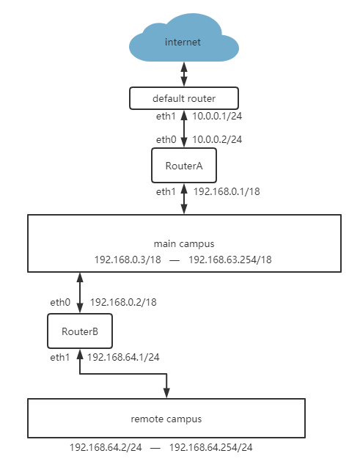

routing table of the RouterA：

|  |  |  |  |  |
| --- | --- | --- | --- | --- |
| Destination | Gateway | Genmask | Flags | Iface |
| 127.0.0.1 | 255.0.0.0 | 0.0.0.0 | U | lo |
| 0.0.0.0 | 10.0.0.1 | 0.0.0.0 | UG | eth0 |
| 10.0.0.0 | 10.0.0.1 | 255.255.255.0 | U | eth0 |
| 192.168.0.0 | 0.0.0.0 | 255.255.192.0 | U | eth1 |
| 192.168.64.0 | 192.168.0.2 | 255.255.255.0 | UG | eth1 |